CA1

727721eucs127

Sairam V S

1) i)

package com.testcase;

import org.openqa.selenium.By;

import org.openqa.selenium.WebDriver; import org.openqa.selenium.WebElement;

import org.openqa.selenium.chrome.ChromeDriver; import org.openqa.selenium.chrome.ChromeOptions; import io.github.bonigarcia.wdm.WebDriverManager;

/**

* Hello world!

*

*/

public class App

{

public static void main( String[] args ) throws InterruptedException

{

ChromeOptions co=new ChromeOptions(); co.addArguments ("--remote-allow-origins=*"); WebDriverManager.*chromedriver*().setup (); WebDriver driver=new ChromeDriver();

driver.get("https://[www.amazon.in/](http://www.amazon.in/)"); Thread.*sleep*(2000); driver.manage().window().maximize();

driver.ﬁndElement(By.*xpath*("//*[@id=\"twotabsearchtextbox\"]")).click();

driver.ﬁndElement(By.*xpath*("//*[@id=\"twotabsearchtextbox\"]")).sendKeys("R olex watches");

driver.ﬁndElement(By.*xpath*("//*[@id=\"nav-search-submit-button\"]")).click(); Thread.*sleep*(2000);

driver.navigate().to("https://www.amazon.in/Royal-Luxurious-Daytona-WatchMen/dp/B0B59S78GV/ref=sr_1_2_sspa?keywords=rolex+watches+for+men&qid=1683197909&sprefix=Rolex%2Caps%2C575&sr=8-2-spons&sp_csd=d2lkZ2V0TmFtZT1zcF9hdGY&psc=1") ;

driver.ﬁndElement(By.*xpath*("//*[@id=\"add-to-cart-button\"]")).click();

WebElement

cart=driver.ﬁndElement(By.*xpath*("//*[@id=\"nav-cart-count\"]")); if(cart.getText().equals("1")) {

System.*out*.print("Added to cart is working successfully");

}else {

System.*out*.print("Added to cart is not working successfully");

}

}

}

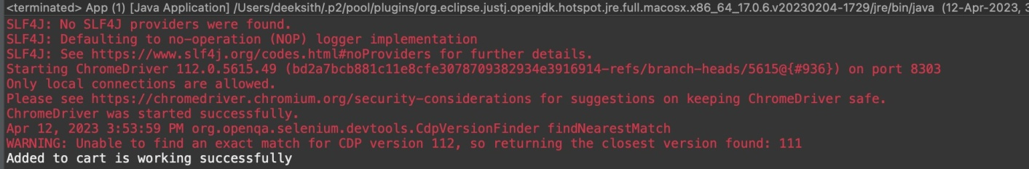Output:

ii)

package com.testcase;

import org.openqa.selenium.By;

import org.openqa.selenium.WebDriver; import org.openqa.selenium.WebElement;

import org.openqa.selenium.chrome.ChromeDriver; import org.openqa.selenium.chrome.ChromeOptions; import io.github.bonigarcia.wdm.WebDriverManager; public class App2 {

public static void main(String[] args) throws InterruptedException { ChromeOptions co=new ChromeOptions();

co.addArguments("--remote-allow-origins=*"); WebDriverManager.*chromedriver*().setup(); WebDriver driver=new ChromeDriver(); driver.get("https://[www.amazon.in/](http://www.amazon.in/)"); Thread.*sleep*(2000);

driver.ﬁndElement(By.*xpath*("//*[@id=\"twotabsearchtextbox\"]")).click();

driver.ﬁndElement(By.*xpath*("//*[@id=\"twotabsearchtextbox\"]")).sendKeys("f ossil watches");

driver.ﬁndElement(By.*xpath*("//*[@id=\"nav-search-submit-button\"]")).click();

Thread.*sleep*(2000);

driver.navigate().to("https://www.amazon.in/Royal-Luxurious-Daytona-WatchMen/dp/B0B59S78GV/ref=sr_1_2_sspa?keywords=rolex+watches+for+men&qid=1683197909&sprefix=Rolex%2Caps%2C575&sr=8-2-spons&sp_csd=d2lkZ2V0TmFtZT1zcF9hdGY&psc=1") ;

driver.ﬁndElement(By.*xpath*("//*[@id=\"add-to-cart-button\"]")).click(); driver.navigate().to("https://[www.amazon.in/gp/cart/view.html?ref_=nav_cart](http://www.amazon.in/gp/cart/view.html?ref_=nav_cart)"

);

Thread.*sleep*(2000);

WebElement cart=driver.ﬁndElement(By.*xpath*("/html/body/div[1]/div[2]/div[3]/div[5]/div/div [2]/div[1]/div/form/div[2]/div[3]/div[4]/div/div[2]/div[1]/span[1]/span/span[1]/span/ span/span/span/span[2]"));

if(cart.getText().equals("0")) {

System.*out*.print("Removing from cart is working successfully");

}else {

System.*out*.print("Removing from cart is not working successfully");

}

}

}

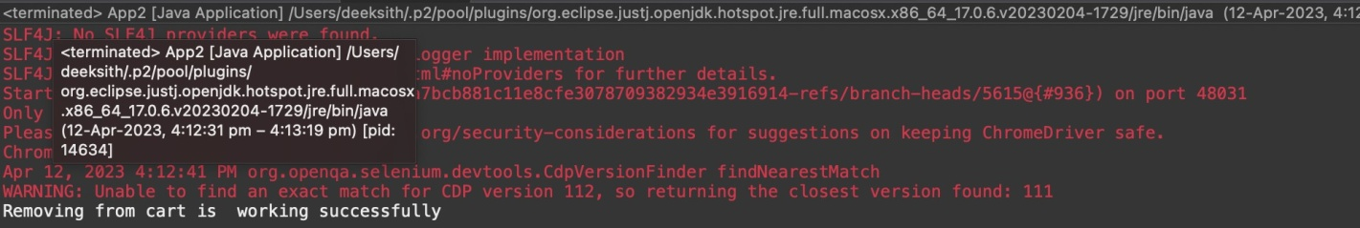Output:

iii)

package com.testcase;

import org.openqa.selenium.By;

import org.openqa.selenium.WebDriver; import org.openqa.selenium.WebElement;

import org.openqa.selenium.chrome.ChromeDriver; import org.openqa.selenium.chrome.ChromeOptions; import io.github.bonigarcia.wdm.WebDriverManager; public class App2 {

public static void main(String[] args) throws InterruptedException { ChromeOptions co=new ChromeOptions();

co.addArguments("--remote-allow-origins=*"); WebDriverManager.*chromedriver*().setup(); WebDriver driver=new ChromeDriver(); driver.get("https://[www.amazon.in/](http://www.amazon.in/)"); Thread.*sleep*(2000);

driver.ﬁndElement(By.*xpath*("//*[@id=\"twotabsearchtextbox\"]")).click();

driver.ﬁndElement(By.*xpath*("//*[@id=\"twotabsearchtextbox\"]")).sendKeys("f ossil watches");

driver.ﬁndElement(By.*xpath*("//*[@id=\"nav-search-submit-button\"]")).click(); Thread.*sleep*(2000);

driver.navigate().to("https://www.amazon.in/Royal-Luxurious-Daytona-WatchMen/dp/B0B59S78GV/ref=sr_1_2_sspa?keywords=rolex+watches+for+men&qid=1683197909&sprefix=Rolex%2Caps%2C575&sr=8-2-spons&sp_csd=d2lkZ2V0TmFtZT1zcF9hdGY&psc=1") ;

driver.ﬁndElement(By.*xpath*("//*[@id=\"add-to-cart-button\"]")).click();

driver.navigate().to("https://[www.amazon.in/gp/cart/view.html?ref_=nav_cart](http://www.amazon.in/gp/cart/view.html?ref_=nav_cart)"

);

driver.ﬁndElement(By.*xpath*("//*[@id=\"a-autoid-0\"]")).click(); driver.ﬁndElement(By.*xpath*("//*[@id=\"quantity_2\"]")).click(); Thread.*sleep*(2000);

WebElement

cart=driver.ﬁndElement(By.*xpath*("//*[@id=\"nav-cart-count\"]")); if(cart.getText().equals("2")) {

System.*out*.print("Updating cart is working successfully");

}else {

System.*out*.print("Updating cart is not working successfully");

}

}

}

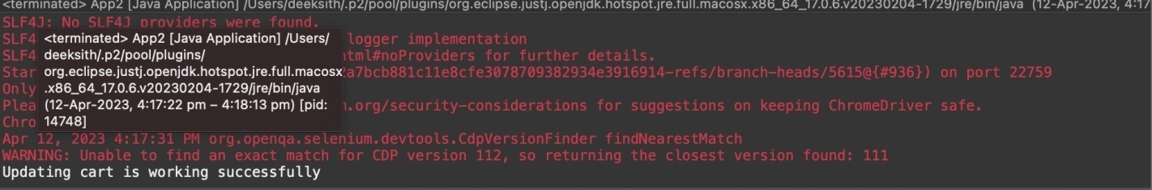Output:

iv)

package com.testcase;

import org.openqa.selenium.By;

import org.openqa.selenium.WebDriver;

import org.openqa.selenium.WebElement;

import org.openqa.selenium.chrome.ChromeDriver; import org.openqa.selenium.chrome.ChromeOptions; import io.github.bonigarcia.wdm.WebDriverManager; public class App2 {

public static void main(String[] args) throws InterruptedException { ChromeOptions co=new ChromeOptions();

co.addArguments("--remote-allow-origins=*"); WebDriverManager.*chromedriver*().setup(); WebDriver driver=new ChromeDriver(); driver.get("https://[www.amazon.in/](http://www.amazon.in/)"); Thread.*sleep*(2000);

driver.ﬁndElement(By.*xpath*("//*[@id=\"twotabsearchtextbox\"]")).click();

driver.ﬁndElement(By.*xpath*("//*[@id=\"twotabsearchtextbox\"]")).sendKeys("f ossil watches");

driver.ﬁndElement(By.*xpath*("//*[@id=\"nav-search-submit-button\"]")).click(); Thread.*sleep*(2000);

driver.navigate().to("https://www.amazon.in/Royal-Luxurious-Daytona-WatchMen/dp/B0B59S78GV/ref=sr_1_2_sspa?keywords=rolex+watches+for+men&qid=1683197909&sprefix=Rolex%2Caps%2C575&sr=8-2-spons&sp_csd=d2lkZ2V0TmFtZT1zcF9hdGY&psc=1") ;

driver.ﬁndElement(By.*xpath*("//*[@id=\"add-to-cart-button\"]")).click(); driver.ﬁndElement(By.*xpath*("//*[@id=\"sc-buy-box-ptc-button\"]/span/input"))

.click();

WebElement

ele=driver.ﬁndElement(By.*xpath*("//*[@id=\"authportal-main-section\"]/div[2]/ div/div[1]/form/div/div/div/h1"));

String actual=ele.getText(); System.*out*.println(actual); String expected="Sign in"; if(actual.equals(expected)) {

System.*out*.print("Navigated to sigin page");

}

}

}

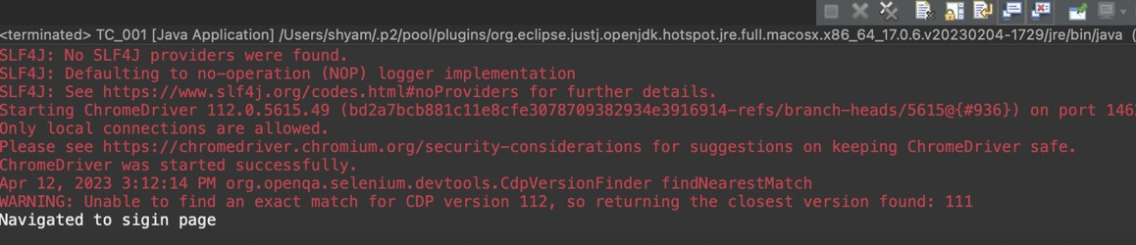Output:

2)

package com.testcase; import java.util.List;

import org.openqa.selenium.By; import org.openqa.selenium.Keys;

import org.openqa.selenium.WebDriver; import org.openqa.selenium.WebElement;

import org.openqa.selenium.chrome.ChromeDriver; import org.openqa.selenium.chrome.ChromeOptions; import io.github.bonigarcia.wdm.WebDriverManager; public class App2 {

public static void main( String[] args ){ ChromeOptions co=new ChromeOptions(); co.addArguments("--remote-allow-origins=*");

WebDriverManager.*chromedriver*().setup();//setting up chrome driver WebDriver driver=new ChromeDriver(); driver.get("https://[www.amazon.in](http://www.amazon.in/)");

driver.ﬁndElement(By.*xpath*("//*[@id=\"twotabsearchtextbox\"]")).sendKeys("S hoes");

driver.ﬁndElement(By.*xpath*("//*[@id=\"twotabsearchtextbox\"]")).sendKeys(*K eys*.*ENTER*);

String a=driver.getTitle(); if(a.equals("Amazon.in : Shoes")) { System.*out*.println("Title is Matched\n");

}

else {

System.*out*.println("Title is Mismatched");

}

List<WebElement> li=driver.ﬁndElements(By.*className*("s-line-clamp-2")); for(int i=0;i<5;i++) {

System.*out*.println(li.get(i).getText());

}

driver.ﬁndElement(By.*xpath*("//*[@id=\"p_36/1318505031\"]/span/a/span")).click ();

WebElement b=driver.ﬁndElement(By.*xpath*("//*[@id=\"search\"]/div[1]/div[1]/div/span[1]/div[ 1]/div[2]/div/div/div/div/div/div/div/div[2]/div/div/div[3]/div[1]/div/div[1]/div[2]/a/sp an[1]/span[2]/span[2]"));

System.*out*.print("Price 2,000-10,000 :"+b.getText());

driver.ﬁndElement(By.*xpath*("//*[@id=\"p_89/Samsung\"]/span/a/div/label/i")).c lick();

WebElement c=driver.ﬁndElement(By.*xpath*("//*[@id=\"search\"]/div[1]/div[1]/div/span[1]/div[1

]/div[2]/div/div/div/div/div/div[2]/div/div/div[1]/h2/a/span")); System.*out*.print("Price 2,000-10,000 & Puma: "+ c.getText());

}

}

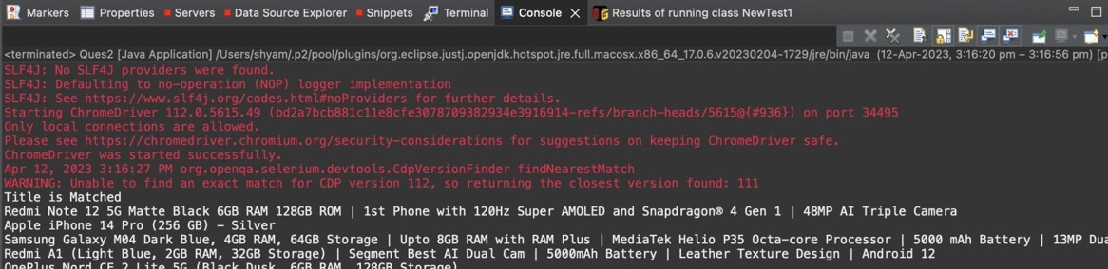Output:

3)

package com.testcase; import java.util.List;

import org.openqa.selenium.By; import org.openqa.selenium.Keys;

import org.openqa.selenium.WebDriver; import org.openqa.selenium.WebElement;

import org.openqa.selenium.chrome.ChromeDriver; import org.openqa.selenium.chrome.ChromeOptions; import io.github.bonigarcia.wdm.WebDriverManager; public class App2 {

public static void main( String[] args ){ ChromeOptions co=new ChromeOptions(); co.addArguments("--remote-allow-origins=*"); WebDriverManager.*chromedriver*().setup(); WebDriver driver=new ChromeDriver();

driver.get("https://[www.amazon.in/ap/signin?openid.pape.max_auth_age=0&](http://www.amazon.in/ap/signin?openid.pape.max_auth_age=0) openid.return_to=https%3A%2F%2Fwww.amazon.in%2F%3Fref_%3Dnav_ya_s ignin&openid.identity=http%3A%2F%2Fspecs.openid.net%2Fauth%2F2.0%2Fi dentiﬁer_select&openid.assoc_handle=inﬂex&openid.mode=checkid_setup& openid.claimed_id=http%3A%2F%2Fspecs.openid.net%2Fauth%2F2.0%2Fide ntiﬁer_select&openid.ns=http%3A%2F%2Fspecs.openid.net%2Fauth%2F2.0&"

);

//sigin driver.ﬁndElement(By.*xpath*("//*[@id=\"ap_email\"]")).click();

driver.ﬁndElement(By.*xpath*("//*[@id=\"ap_email\"]")).sendKeys("6382023425")

;

driver.ﬁndElement(By.*xpath*("//*[@id=\"continue\"]")).click();

driver.ﬁndElement(By.*xpath*("//*[@id=\"ap_password\"]")).click();

driver.ﬁndElement(By.*xpath*("//*[@id=\"ap_password\"]")).sendKeys("deeksith 28");

driver.ﬁndElement(By.*xpath*("//*[@id=\"signInSubmit\"]")).click(); driver.ﬁndElement(By.*xpath*("//*[@id=\"nav-link-accountList\"]")).click();

WebElement

acc=driver.ﬁndElement(By.*xpath*("//*[@id=\"a-page\"]/div[2]/div/div[1]/h1")); String actual=acc.getText();

String expected="Your Account"; if(actual.equals(expected)) {

System.***ouĒ***.println("Your Account page is displayed");

}

driver.ﬁndElement(By.*xpath*("//*[@id=\"a-page\"]/div[2]/div/div[2]/div[1]/a/div")). click();

WebElement

ord=driver.ﬁndElement(By.*xpath*("//*[@id=\"a-page\"]/section/div[1]/div[2]/div[1

]/h1"));

String act=ord.getText(); String exp="Your Orders"; if(act.equals(exp)) {

System.***ouĒ***.println("Your Order page is displayed");

}

//

driver.ﬁndElement(By.xpath("//*[@id=\"a-page\"]/div[2]/div/div[2]/div[1]/a/div"))

.click();

// WebElement

trac=driver.ﬁndElement(By.xpath("//*[@id=\"a-page\"]/section/div[1]/div[2]/div[ 1]/h1"));

String act1=ord.getText(); String exp1="Your orders"; if(act.equals(exp)) {

System.***ouĒ***.println("User is able to track package");

}

// driver.ﬁndElement(By.xpath("//*[@id=\"pop\"]/div/div[2]/div/div[1]/div/div[3]/di v/div/div/div/div[2]/div/div/a")).click();

System.***ouĒ***.println("User is able to view their products");

}

}